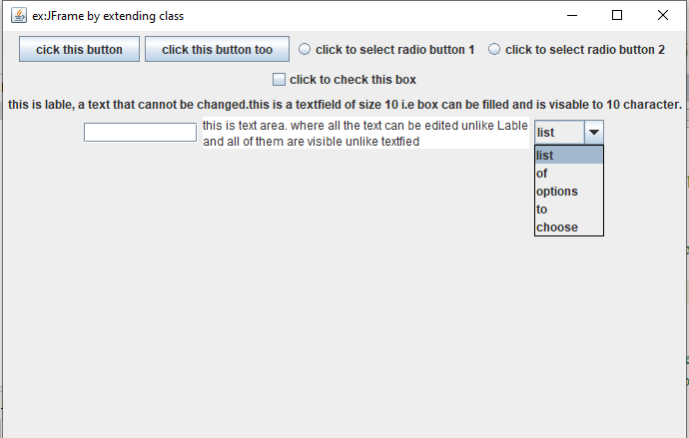

/*

* Click nbfs://nbhost/SystemFileSystem/Templates/Licenses/license-default.txt to change this license

*/

package com.mycompany.jframeexamples;

import java.awt.FlowLayout;

import javax.swing.JButton;

import javax.swing.JCheckBox;

import javax.swing.JComboBox;

import javax.swing.JFrame;

import javax.swing.JLabel;

import javax.swing.JRadioButton;

import javax.swing.JTextArea;

import javax.swing.JTextField;

/**

*

* @author Dell

*/

public class JFrameExamples extends JFrame {

JButton butn;

JRadioButton jrabtn;

JCheckBox jchkbx;

JLabel jlab;

JTextField jtxtfld;

JTextArea jta;

JComboBox jcombx;

String options[] = {"list" , "of" , "options" ,"to","choose"};

JFrameExamples(){

setTitle("ex:JFrame by extending class ");

butn = new JButton("cick this button");

add(butn);

butn = new JButton("click this button too");

add(butn);

jrabtn = new JRadioButton("click to select radio button 1");

add(jrabtn);

jrabtn = new JRadioButton("click to select radio button 2");

add(jrabtn);

jchkbx = new JCheckBox("click to check this box");

add(jchkbx);

jlab = new JLabel("""

this is lable, a text that cannot be changed.

this is a textfield of size 10 i.e box can be filled and is visable to 10 character.""");

add(jlab);

jtxtfld = new JTextField(10);

add(jtxtfld);

jta = new JTextArea("""

this is text area. where all the text can be edited unlike Lable

and all of them are visible unlike textfied""");

add(jta);

jcombx = new JComboBox(options);

add(jcombx);

setLayout(new FlowLayout());

setSize(700,1000);

setDefaultCloseOperation(JFrame.EXIT_ON_CLOSE);

setVisible(true);

}

public static void main(String[] args) {

JFrameExamples jfe = new JFrameExamples();

}

}